CO88 -

Functionality
During Production order settlement, either Work In Process (if incomplete delivery) or Variance (if complete delivery) is posted. If Variance is posted, any WIP posted before will be reversed.

Scenario
You want to post WIP or Variance after WIP & Variance calculation.

Requirements

Work In Process and Variance was calculated.

Menu Path | Accounting →Controlling →Product Cost Controlling →Cost Object Controlling →Product Cost by Order→Period-End Closing→Single Functions →Settlement→CO88 - Collective Processing
Transaction Code | CO88

1. Double click on CO88 - Collective Processing.
Actual Settlement: Production/process orders

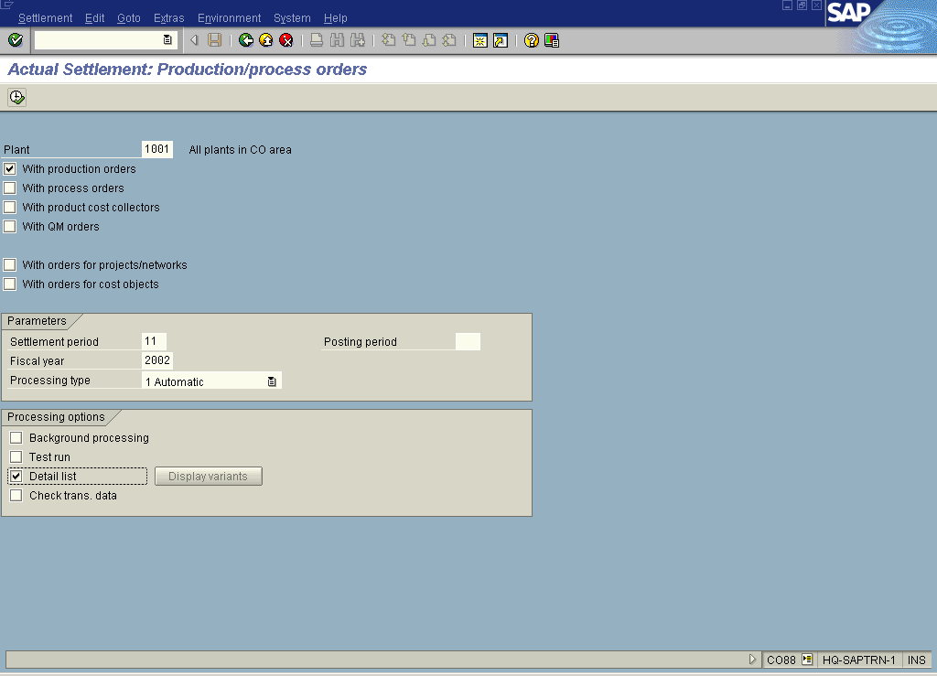
2. Update the following fields:

Field Name | Field Description | Values
Plant | Code identifying the operational unit of the company where the material is manufactured and stored. | Example: 1001
Period | Number identifying a fiscal month. | Example: 11
Fiscal year | Fiscal year for which you calculate variance. | Example: 2002

3. Click the With process orders checkbox to deselect.
4. Click the With product cost collectors checkbox to deselect.
5. Click the With QM orders checkbox to deselect.
6. Click the Test run checkbox to deselect.
7. Click the Detail list checkbox to select.
8. Click the Execute button.
9. Click the Detail lists button.

Actual Settlement: Production/process orders Detail list

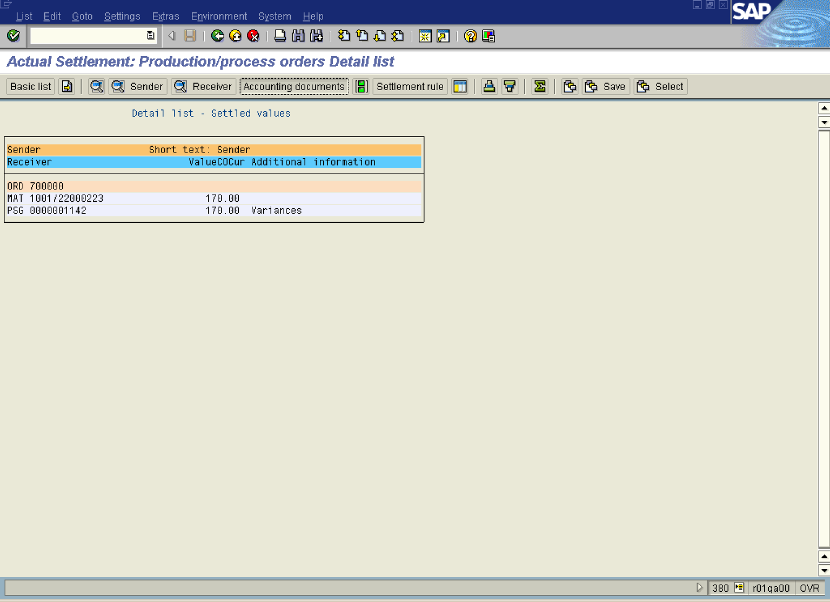

10. Select the relevant line and click the Accounting documents button.

List of Documents in Accounting

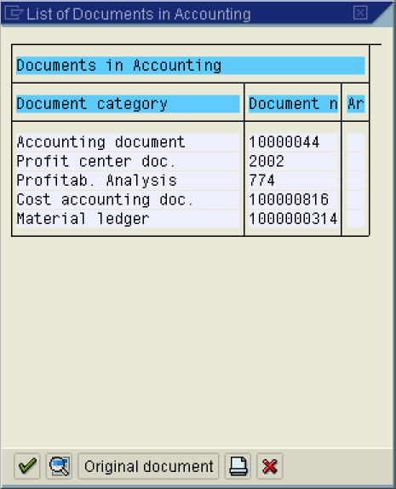

11. Click the Continue button.

Display Document: Overview

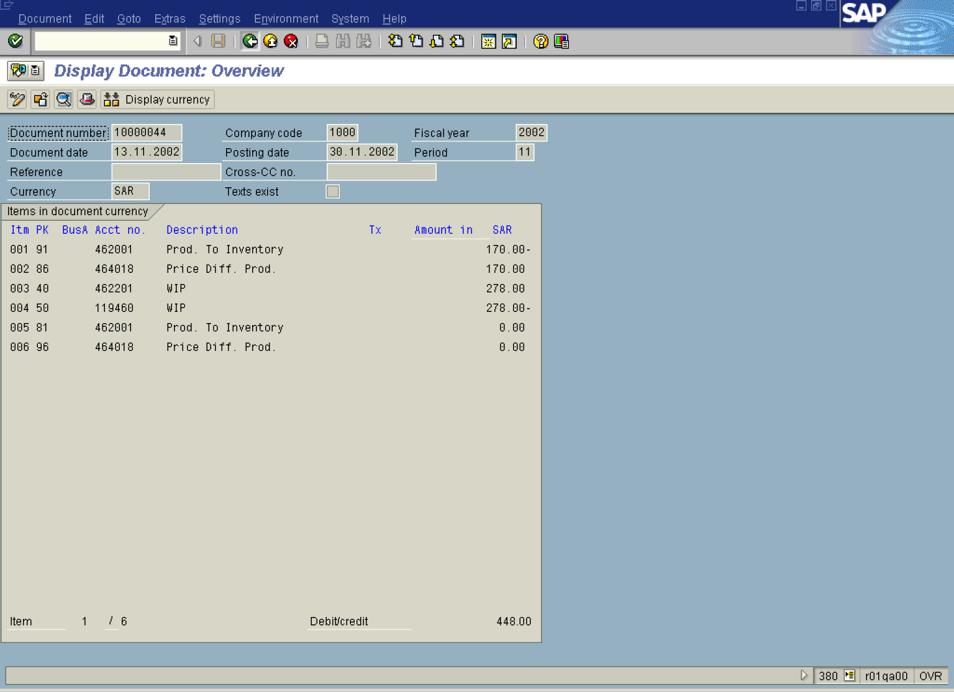

12. Click the Back button.

List of Documents in Accounting

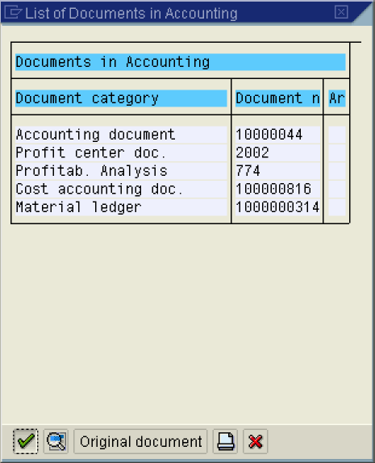

13. Click the Cancel button.

Actual Settlement: Production/process orders Detail list

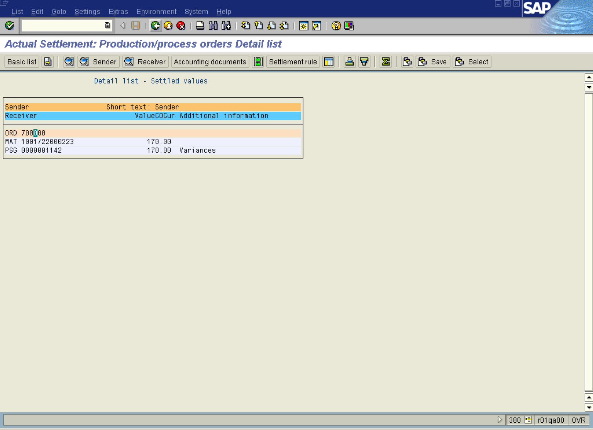

14. Click the Back button.

15. Click the Back button.

